



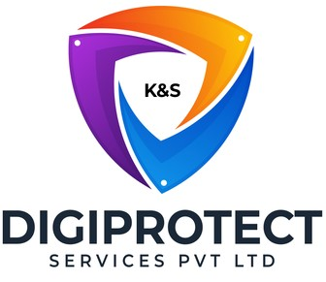

INITIAL
ASSESSMENT
REPORT

DATE: 27th May 2024
Credit

VERSION: 1.0

Document History
Document version | Remarks | Submitted  By | Submission  Date | Approved BY | Approval  Date
1.0 | First Draft | k&S Digiprotect | 27th May 2024

K&S Digiprotect Services Pvt. Ltd.
Date of Discussion: Date of Release:
Version: 1.0
Date of Release: 15th April 2024

Table of Contents
Introduction 4
Objectives 4
General Information 5
SPOC Information 5
Department Hierarchy* 6
Key Processes 7
Data Flow Diagram (DFD) 9
Data Mapping and Inventory 10
Conclusion 11
Appendices 12
Appendix A 12

Introduction
The credit department of India Shelter Finance Corporation Limited acts as the financial gatekeeper. They assess loan applicants, determine creditworthiness, and approve loans with minimal risk. They also monitor repayments.
This report encapsulates critical insights for As-Is study, derived from the initial interview conducted with the credit Department of India Shelter Finance Corporation Limited (ISFC) for the implementation of ISO/IEC 27001:2022 and compliance with the Digital Personal Data Protection Act (DPDPA).
The overarching objectives of this interview were dual fold: first, to gain an understanding of the departmental structure, and second, to delve into the core operational processes of the Credit Department. Additionally, the interview aimed to assess the existing information security practices, focusing on evaluating adherence to DPDPA requirements and the readiness for ISO/IEC 27001:2022 implementation.
By delving into the details of the department's organizational setup, operational workflows, and data handling procedures, this report aims to identify both the strengths and areas of improvement in information security management and DPDPA compliance within the department.

Objectives
- Understand the departmental hierarchy and reporting structure
- Learn the existing processes of ISFC’s Credit Department
- Mapping of existing processes with documented processes
- Offer recommendations to optimize the existing processes

General Information
Organization Name | India Shelter Finance Corporation Limited
Department Name | Credit Department
Date of the Assessment | 2nd May 2024
Location | Basement, India shelter HQ, Gurugram
Meeting Duration | 45 minutes
Attendees (ISFC) | Akshay Prajapati, Savan Chauhan, Sunil Kumar Sharma
Attendees (Digiprotect) | Lalit Mohan Joshi, Adhita Razdan

SPOC Information
Project SPOC: Dheeraj Yadav
Contact Information:
Email ID: dheeraj.yadav@indiashelter.in

Project Coordinator: Sunil Kumar Sharma
Contact Information:
Email ID: sunil.sharma2@indiashelter.in

Department SPOC: Savan Chauhan
Contact Information:
Email ID: savan.chauhan@indiashelter.in

Department Hierarchy*

* As informed during the meeting

Key Processes
S. No | Key Activities | Observations and Asks | Remarks
 | Credit requests  - Customer credit requests are automatically queued in Salesforce after approval from operations department.  - Bank credit manager performs a Screening on Customer about:  - CIBIL check  - Eligibility (Credit policies)  - KYC  - Residence/Business place  - After positive Feedback from Bank credit manager the case is taken up for appraisal by the credit department.  - Reverification is documents is done by:  - RCO: Access to customer information-  - Self-employed/salaried  - Address  - Application form  - Photo  - Head office team | - Deviations can also be approved and there is  Hind-sighting involved in the verification process.  - They have both digital and offline sources for customer data (KYC document, Bank account details, Family background, Salaried/Self-employed, Property papers, ITR, Income documents)  - Physical copies of Property papers are stored in the branch
 | Credit approval  - Loan amount is decided on the basis of:  - Loan to value-The LTV ratio serves as a quantitative measure of credit risk  - CIBIL score - Credit Information Bureau India Limited. CIBIL score is a key indicator of your past borrowing behaviour and repayment history, making it a valuable tool for assessment.  - Customer profile  - Following a two-stage customer verification process incorporating a third-party creditworthiness assessment, the maximum approvable credit limit is determined according to the Underwriting conducted  - Underwriters do a CAM check and mark customers subjectively which determines the amount of credit that can be allotted to the customer.  - CAM (Customer Acquisition Management check)-Required to meet compliance and stopping fraudulent loan applications or unqualified borrowers  - Once the file is approved by credit it is sent back to the operations team for disbursement of loan. | NA

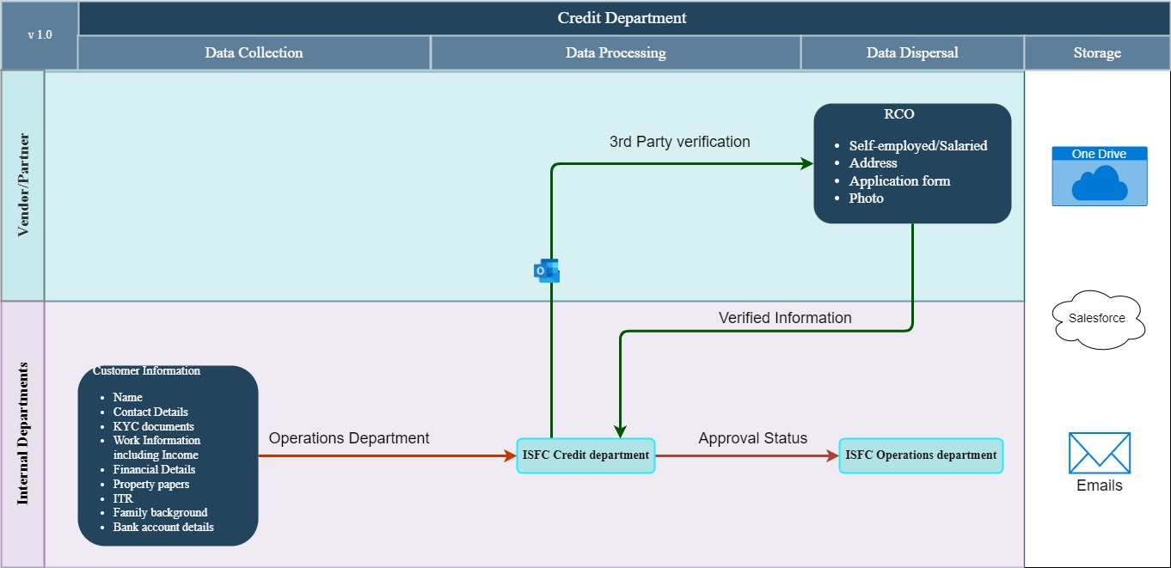
Data Flow Diagram (DFD)

Data Mapping and Inventory
S. No | Data Category | Description | Purpose | Data Owner | Storage Location | Data Classification* | Retention Period | Legal Basis
1. | Customer Information | Personal information of customers  (Self-employed/salaried  Address, Application form, Photo, KYC documents, Bank account details, ITR and Income documents) | Used for identification and approval of credit | Credit department | Salesforce | PII/Sensitive data | Not Defined | Consent
2. | Customer information  (3rd party verification) | Verification for deviations from loan applications if any | Used for Verification of customer provided information | Credit department | Email/  OneDrive | PII/Sensitive data | Not defined | Legitimate interest
3. | Property papers | Physical property papers are also taken as proof | Verification of asset | Branch/  Operations department | CRC Vendor | PII/Sensitive data | Until loan closure | Legitimate interest
*Refer Appendix A

Conclusion
India Shelter Finance Corporation Limited carefully assesses customers creditworthiness and managing risk, the credit department facilitates the responsible lending practices by performing multicomponent checks performed by:
- Bank Credit manager
- H.O team
- RCO (3rd Party verification)
Verification of the customer are done on the following self-reported information:
- Name
- Contact Details
- KYC documents
- Work Information including income
- Financial Details
- Property papers
- ITR
- Family background
- Bank account details
Loan amount is decided upon the following information:
- LTV (Loan to value)
- CIBIL score (Credit Information Bureau India Limited)
- Customer Profile
Underwriters also do CAM (Customer Acquisition Management) checks to meet compliance and mark customers subjectively.
Once all Verification and loan amount is determined the handling of disbursement is Reassigned to the Operations department.

Appendices

Appendix A
Data Classification | Definition
Sensitive Data | Information that, if disclosed, altered, or destroyed without authorization, could cause significant harm to an individual, organization, or entity. This often includes financial records, medical information, and PII.
Restricted Data | Highly sensitive data tightly controlled due to legal, regulatory, or contractual requirements. Access is limited to authorized personnel, and any unauthorized disclosure may result in severe consequences.
Private Data | Information considered confidential and intended solely for specific individuals or groups within an organization. It requires protection from unauthorized access to maintain privacy and uphold confidentiality agreements.
Confidential Data | Privileged or proprietary information of an organization requiring protection from unauthorized access, disclosure, or alteration.
Public Data | Information that is freely available and accessible to the general public without restrictions or limitations. It does not contain sensitive or confidential information and can be openly accessed and used for various purposes such as research, analysis, and public interest initiatives.
PII (Personally Identifiable Information) | Data that can identify, contact, or locate an individual, either alone or in combination with other information. For example - names, addresses, official identifiers (Aadhar, Pan, DL, biometrics, etc).
Non-PII | Data that, while not personally identifiable, however may still require protection due to its sensitivity or confidentiality. This may include corporate financial information, proprietary research data, or internal communications.

-----------------------------------------End of report for Credit------------------------------

